Project #1 Report

ECE 4320

Chan Kim/chkz6d

2/3/2021

**Objective:**

Build and design an automatic door by using Arduino. The door opens automatically by ultrasonic sensor detecting a person standing closer than 0.05m. The LED will turns on whenever the ultrasonic sensor detects a person 0.15m away from the door, and it remains ON until the door closes.

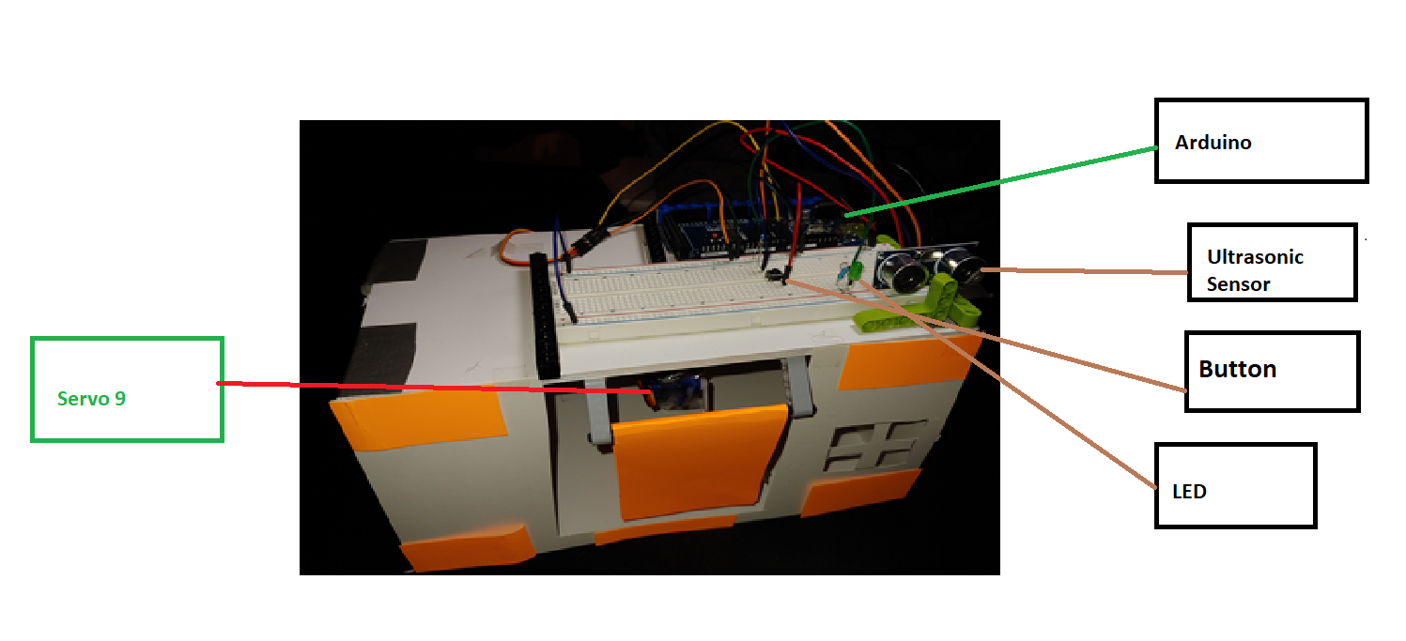**Design:**

**Servo 9:** The motor that mechanically opens and closes the door

**Ultrasonic Sensor:** The electronic device that measures the distance of a target object by sending ultrasonic sound waves.

**Button:** This function is to open and close the door manually.

**LED:** The LED turns on and off whenever the door is opened or closed.

Using distance calculation,

Travel_distance = speed * travel_time

=

Travel distance = 0.017 * pulse_duration

The servo 9 can opens a door and turns on LED when a person stands closer than 0.05m to the door. When a person stand is 0.15m from the door, a light is turned on and remains on, as long as the door is open.

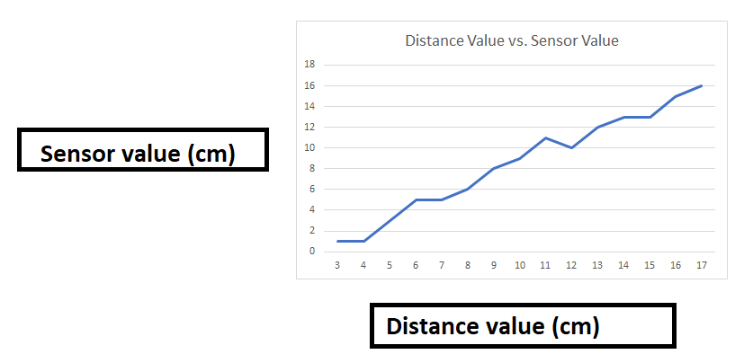

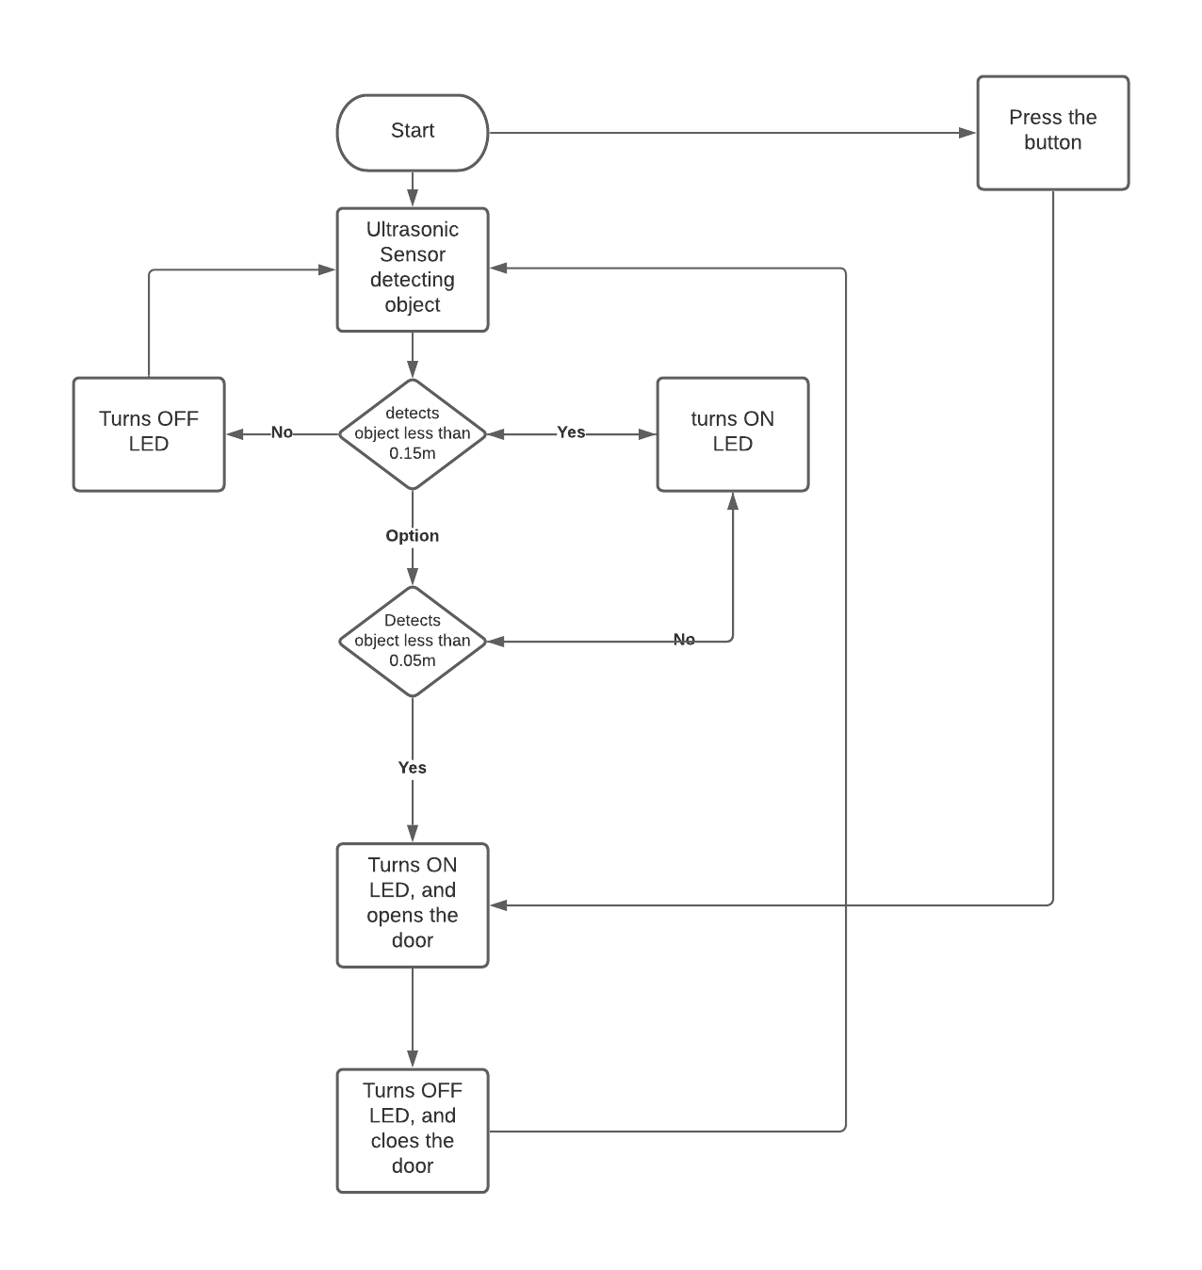Flowchart:

The biggest challenge of this project was wiring for the circuit. After trying out few different cases, I figured the LED light wasn’t connected to the ground and it affected my whole circuit not to function. Another challenge I had in this project was creating a physical door for this project. With the limited supplies it was difficult to create a door that I planned for. Get in a right angle and right distance for door was the biggest challenge.

From this project I have learned how to do wiring and as well as working with Arduino. I get to know better with Arduino after this project.

For future improvements, I want to make the design more stable and cleaner. My design wasn’t stable enough the servo 9 and the door was kept on disconnecting from each other. Also, if it’s possible, I would like to make the volume for my project as minimum as possible. Instead of using a big breadboard, I am going to use a small bread board.

Appendix:

//Servo9

#include<Servo.h>

int servoPin=6;

Servo Servo1;

//UltraSonicSensor variables

int trigPin = 4;

int echoPin = 3;

float duration_us, distance_cm;

//LED lights

const int LED_PIN = 2;

//BUTTON

const int BUTTON_PIN = 7;

int buttonState = 0;

void setup()

{

// begin serial port

Serial.begin (9600);

// configure the trigger pin to output mode

pinMode(trigPin, OUTPUT);

// configure the echo pin to input mode

pinMode(echoPin, INPUT);

//servo setup

Servo1.attach(servoPin);

//LED setup

pinMode(LED_PIN, OUTPUT);

//BUTTON setup

pinMode(BUTTON_PIN, INPUT_PULLUP);

}

void loop()

{

//read the state of the switch/button

buttonState = digitalRead(BUTTON_PIN);

Serial.println(buttonState);

// when button is pressedq

if (buttonState == HIGH)

{

//LED ON and OFF

digitalWrite(LED_PIN, HIGH);

//OPENS THE DOOR

Servo1.write(180);

delay(6000);

Servo1.write(0);

delay(3000);

digitalWrite(LED_PIN, LOW);

exit;

}

// generate 10-microsecond pulse to TRIG pin

digitalWrite(trigPin, HIGH);

delayMicroseconds(10);

digitalWrite(trigPin, LOW);

// measure duration of pulse from ECHO pin

duration_us = pulseIn(echoPin, HIGH);

// calculate the distance

distance_cm = 0.017 * duration_us;

// print the value to Serial Monitor

Serial.print("Distance: ");

Serial.print(distance_cm);

Serial.println(" cm");

delay(500);

//When a person is 15cm away from the door, turns a light on

if(distance_cm <= 15)

{

//LED on

digitalWrite(LED_PIN, HIGH);

//When a person is 5 cm away from the door, opens the door

if (distance_cm <= 5)

{

//OPENS THE DOOR

Servo1.write(360);

delay(6000);

Servo1.write(0);

delay(2000);

digitalWrite(LED_PIN, LOW);

}

}

//The light turns off when a person is 30 cm away from the door

if (distance_cm >= 30)

{

digitalWrite(LED_PIN, LOW);

}

}